**The False Position Method**

**Theory**

This is the oldest method for finding the real root of a non linear equation f(x)=0 and closely resembles the bisection method. In this method, also known as regula falsi or the method of chords. Here two point a and b are chosen in such a way that f(a) and f(b) are of opposite signs. Hence a root must lie in between these points. The equation of the chord joining the two points [a,f(a)] and [b,f(b)] is given by,

a*f(b) – b*f(a)

x = -------------------- ………………… (1)

f(b) – f(a)

This method’s procedure is same as the bisection method where the value of a and b changes with respect to the sign of the f(a) and f(x). The only difference between the false position and the bisection method is the equation for determining the root. (Equation 1).

**Code**

#include<bits/stdc++.h>

using namespace std;

double f(double x)

{

return (x*x*x+x-1);

}

int main()

{

double a,b,x1,x2;

cout<<"Enter the value of a: ";

cin>>a;

cout<<"Enter the value of b: ";

cin>>b;

if(f(a)*f(b)>0)

cout<<"Wrong Assumption"<<endl;

else {

cout<<"--------------------------------------------------------"<<endl;

cout<<" a b x1 f(x1) Error Rate \n";

cout<<"--------------------------------------------------------"<<endl;

x1=(a*f(b)-b*f(a))/(f(b)-f(a));

do

{

printf(" %0.4lf %0.4lf %0.4lf %0.4lf %0.6lf \n",a,b,x1,f(x1),fabs(x2-x1));

x2=x1;

if (f(a)*f(x1)<0)

b=x1;

if(f(a)*f(x1)>0)

a=x1;

x1=(a*f(b)-b*f(a))/(f(b)-f(a));

}while(fabs(x2-x1)>=0.00001);

cout<<"\nThe root is:"<<x2<<endl;

}

return 0;

}

**Output**

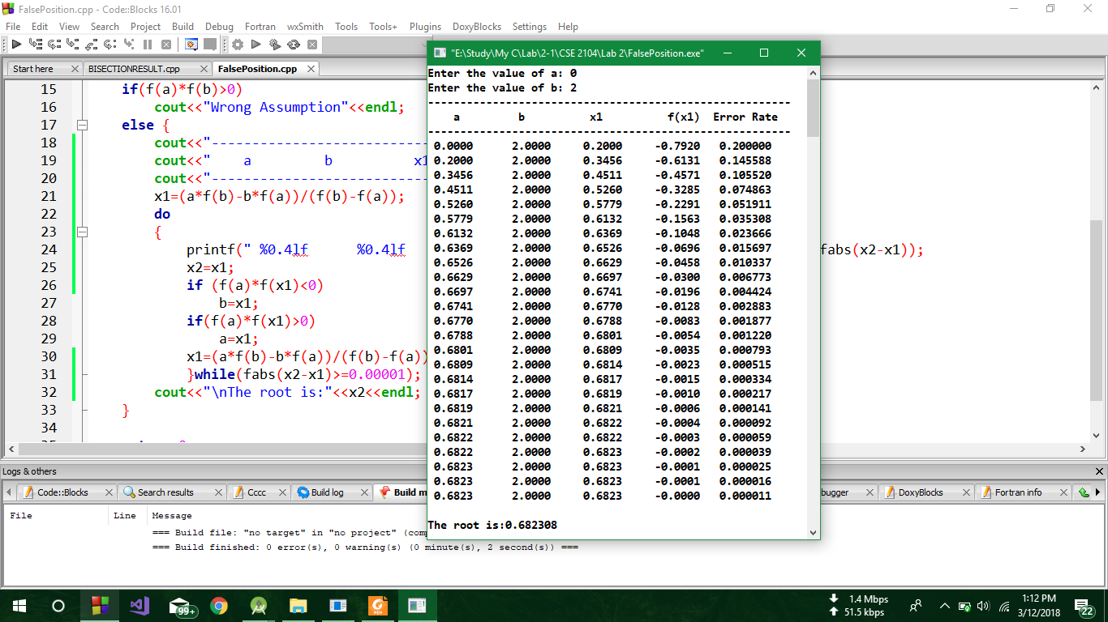

**Discusssion**

In the above code, firstly a function f() was declared as it hold the main equation f(x) = x*x*x+x-1 = 0. Then in the main function a do while loop was executing until the difference of the two consecutive roots of the equation became less than 0.00001. Firstly the value of a and b were taken from the user. In the loop it was checked whether f(a) and f(x) are of opposite signs or not. If so then the value of x was assigned to b, otherwise the value of x is assigned to a. If f(x) becomes 0 then the root x=0. And then this equation x = (a*f(b)-b*f(a))/(f(b)-f(a)) was used. Thus this is the process of False position method and the result and all the values were shown as a tabular form.